Web Engineering

Activity Marks 00

**Instructions**

Work on this lab individually.

You are **NOT** allowed to use the internet, or mobile phone.

**What you have to do**

Program the following tasks. The name of your files will be according to the task given in this lab.

Task 1

Implement a calculator in java which takes two values from the user and an operator as a command line argument and produces the required calculation.

**Sample execution:**

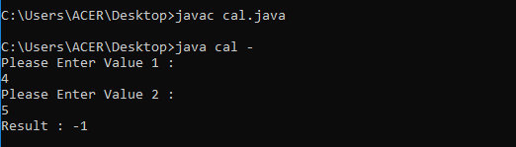

Task 2

Write a Java program to find the number of even and odd integers in a given array.

|  |
| --- |
| Sample Program |
| Original Array: [5, 7, 2, 4, 9]  Count of even numbers : 2  Count of odd numbers : 3 |

Task 3

Write a Java program that takes two positive numbers from the user and output their sum. This operation should be repeated until user enter -1.

Remember, you need to run this operation by creating an object and making a call to its appropriate method(s). Your program should display the number of times, the operation is performed.

|  |
| --- |
| Sample Program |
| Enter Number 1: 10  Enter Number 2: 20  Sum is 30  Operation performed 1 time  Enter Number 1: 15  Enter Number 2: 15  Sum is 30  Operation Performed 2 times  Enter Number 1: -1 |

Task 4

Write a class named **Employee** in Java with attributes *name, e-mail, salary* and *company name*. All data members must be private. Provide *constructor* to initialize private data-members and the *displayInfo()* method to print the information of the employee.

Write a **main()** to show the execution of your code by creating an object and making a call to its appropriate method(s).

Instruction:

* Convert the string arguments into appropriate types using the concept of wrapper classes. e.g., from string to int conversion: int num = Integer.parseInt(“123”);